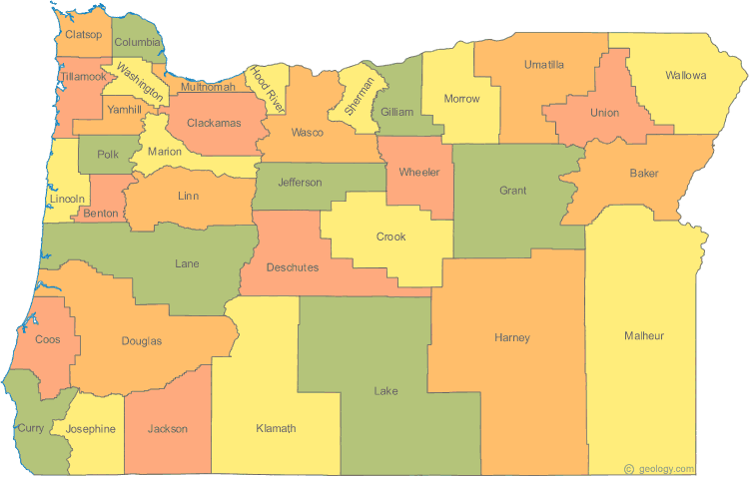
Member Counties: Baker, Benton, Clatsop, Columbia, Coos, Curry, Douglas, Gilliam, Grant, Harney, Hood River, Josephine, Klamath, Lake, Lincoln, Linn, Malheur, Marion, Morrow, Polk, Sherman, Tillamook, Umatilla, Union, Wallowa, Wasco, Wheeler, Yamhill

Agencies Participating in the Rural Oregon Continuum of Care Visibility Group
Client data shared to following agencies:

Champion Team
Clatsop Community Action
Colombia Cascade Housing Corporation
Community Action Partnership of Oregon
Community Action Program of East Central Oregon
Community Action Resource Enterprise, Inc.
Community Action Team
Community Connection of Northeast Oregon
Community in Action
Community Outreach Inc.
Community Services Consortium
Corvallis Housing First
Crossroads Communities
Devereux Center
Helping Hands Re-Entry
Integral Youth Services
Jackson Street Youth Services
Klamath Lake Community Action Services
Linn-Benton Housing Authority
Medicine Wheel Recovery Services, Inc.
Mid-Columbia Community Action Council
Oregon Coast Community Action Network
United Community Action Partnership
Yamhill Community Action Partnership
YCAP – Youth Services

